Industry ready:

Creating repo in git

Copy repo to local

Open repo folder in vs code

Create conda venv

Activate env

Create req.txt flask code

Docker file

Set-up heroku

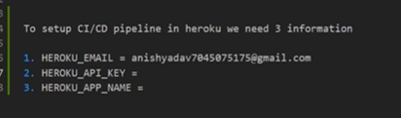

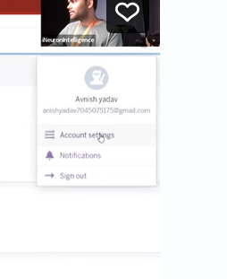

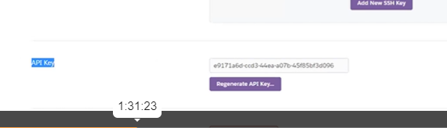

App name

We can create 5 apps

Create new app

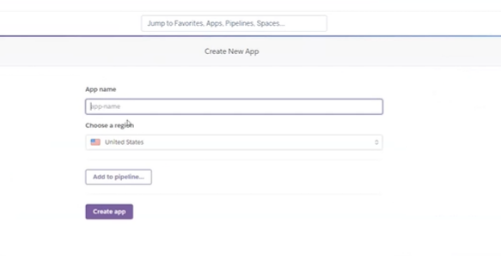

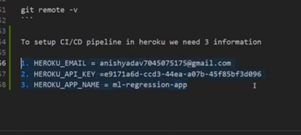

To delete app in Heroku

Go to appl

* Goto setting
* 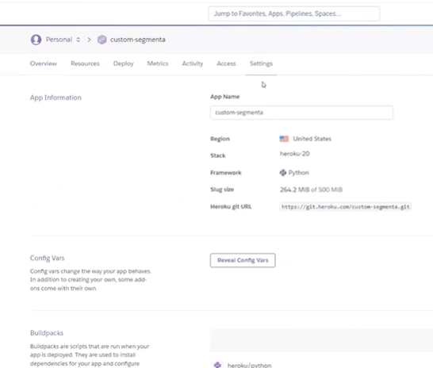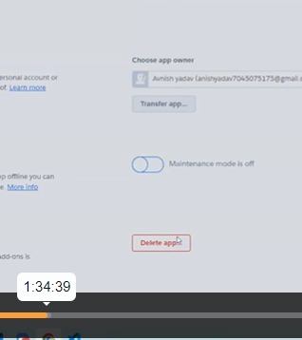
* 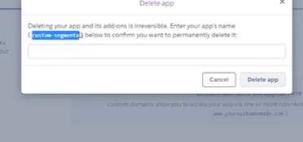
* Copy above mesg
* Paste in below box
* 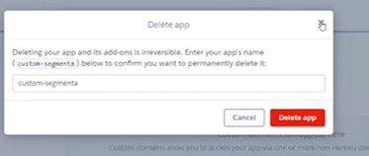
* -------------------------------------------------------
* --------------------------------------------------------------------------------------------------------------------------------

To create a docker file

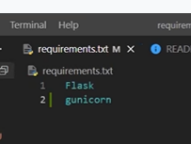

For creating docker image we need to create docker file

First we need tp have base image == where os--- python 3.8

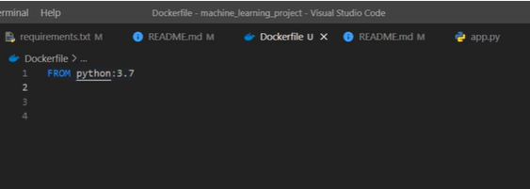

Next we need to mention entire folder

Except virtual environment file

That we should mention in doctor ignore file

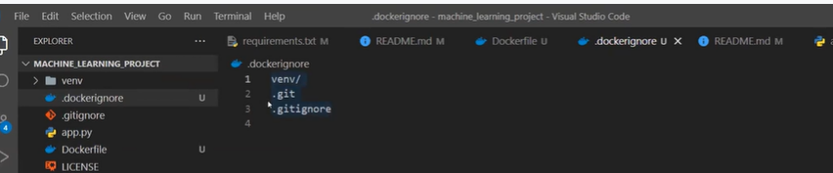

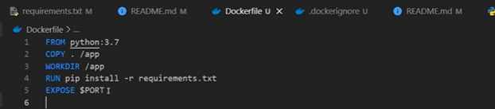

We need to mention command for gunicorn command to run flask app

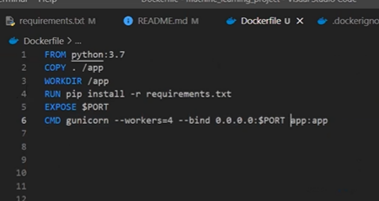

Now building docker image :

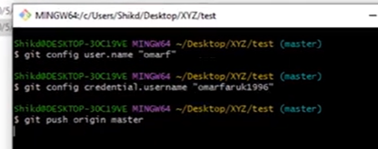

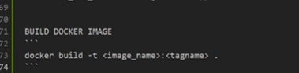

Building docker 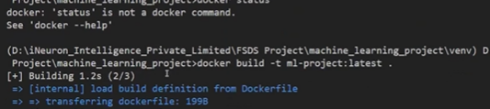



From python 3.7 image it will download one by one

To list docker images

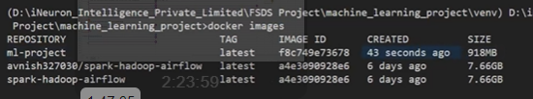

Run docker image

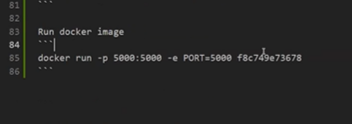

----- its image id

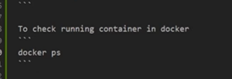

To stop docker container

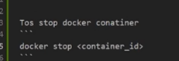

After creating code creating docker image

Update git

Git add .

Git commit

Git push

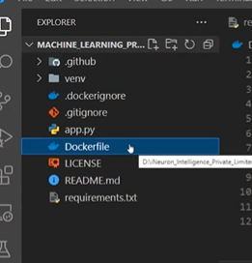

Within github we need to create one more folder– workflow

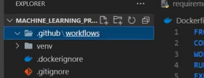

Within workflow one more file must be created

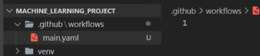

---------------------------------------------------------------------------------------

Once our CI is done we need to create trigger

Trigger triggers the deployment process

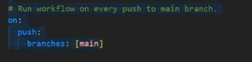

This is the trigger

Whenever we do some changes to main… it create trigger

What ever task we have mention in this file will happen

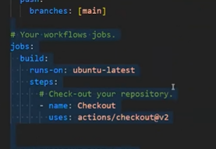

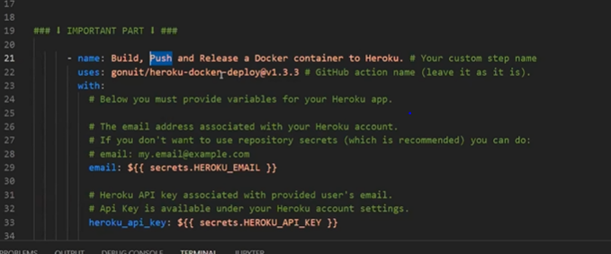

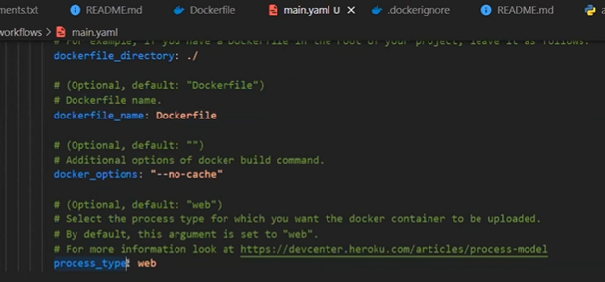

**Above trigger makes automation of creating image – called continuous deployment**

[GitHub - avnyadav/machine_learning_project: This is first machine learning project.](https://github.com/avnyadav/machine_learning_project)

In actions in github- Heroku

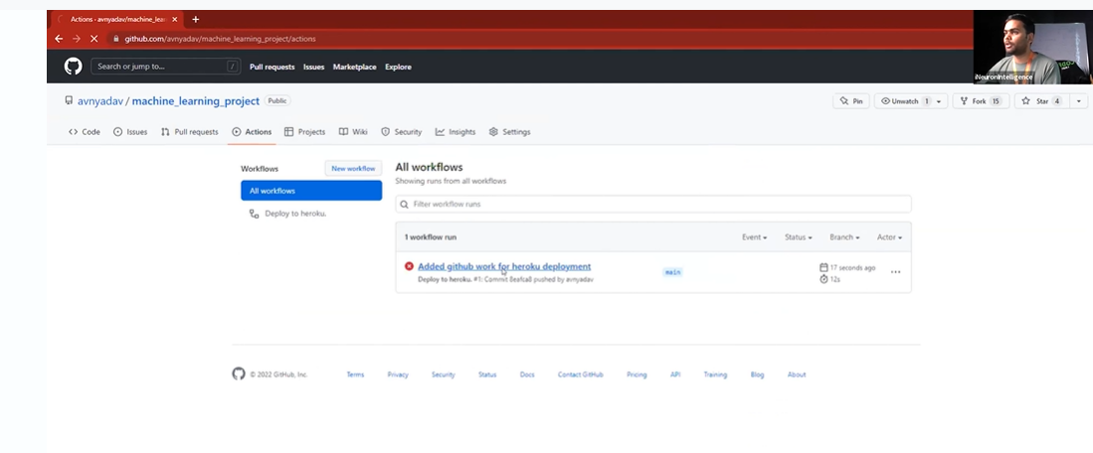

If u don’t provide secret key and credentials image

U must add

Open – repo-settings-secrets-actions

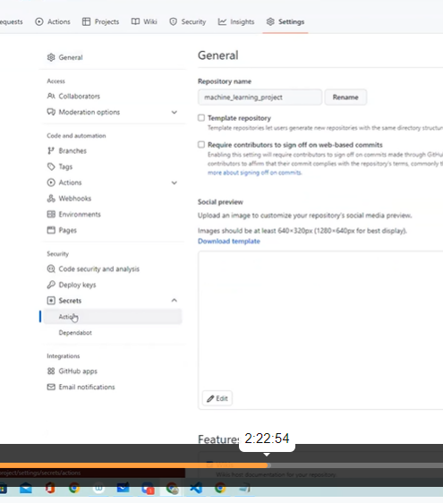

Click on new repo secrets

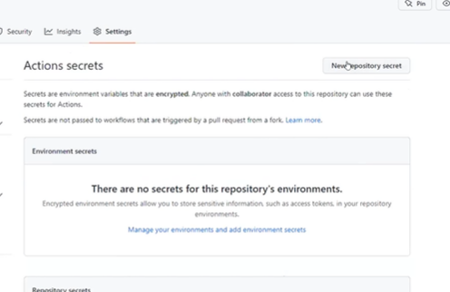

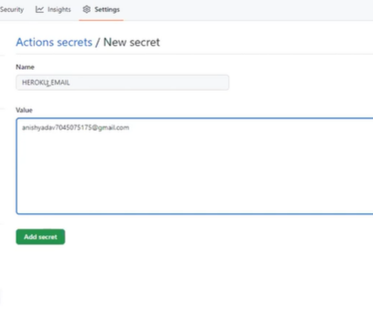

Again click on new repo secret

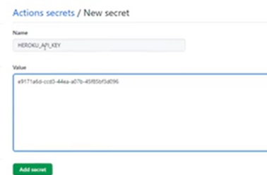

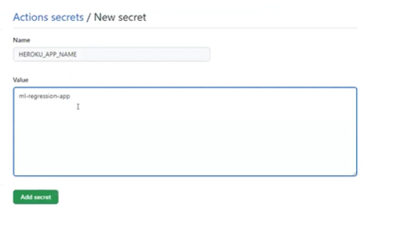

Now click again

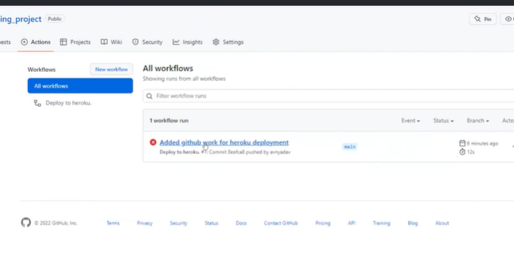

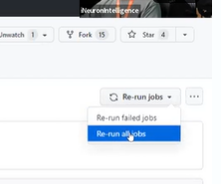

Click on rerun all job

Now make modeification in app.py

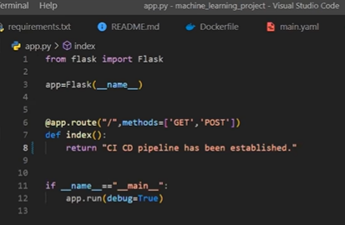

Git add

Git commit

Git push

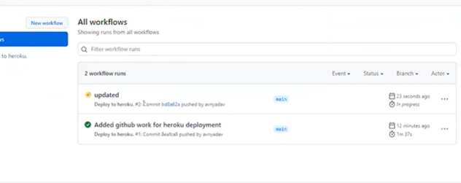

Whenever I push – new version created with new deployment

